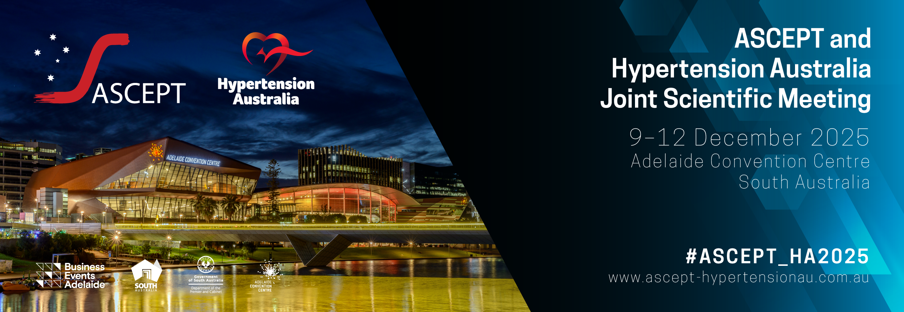

Call for symposia proposals
Submission is now open for proposals for symposia to be presented at the ASCEPT and Hypertension Australia Joint Scientific Meeting to be held from 9 – 12 December 2025. The Joint Scientific Meeting brings together the leading academics, researchers, clinicians, and educators in pharmacology, toxicology, and hypertension and we therefore encourage topics that align with the shared interests of ASCEPT and Hypertension Australia where possible.
ASCEPT and Hypertension Australia recognise the diversity of their membership and are committed to the values, attitudes and conduct of equity, diversity and inclusion to create a collegial, collaborative and successful professional community. The Joint Congress is committed to achieving equity and inclusion through balancing representation across symposia proposals in alignment with the diverse membership composition. Your application should describe aspects of equity, diversity and inclusivity with the selection of chairs and speakers, including the proportion of male and female contributors, the career level (early, mid, senior), diversity of geographical locations, and minority group representation. Download the ASCEPT policy here.
The deadline for submitting symposia proposals is Friday 2 May 2025.

Symposium format and evaluation process
Each symposium will run for two hours and is to incorporate four speakers, or three speakers and a panel discussion, each with an allotted presentation time of 30 minutes: 20 minutes plus 5-10 minutes to allow audience members to ask questions of presenters and for an exchange of views.
- Please ensure that you have sought agreement from speakers to participate in your symposium before including them
in the application.
- Symposia will be ranked by the organising committee of the Joint Scientific Meeting and relevant delegates (e.g. ASCEPT Special Interest Group chairs, Hypertension Australia board).
- Applicants will be advised via email whether their symposium proposal has been accepted by Monday 26 May 2025.
- Successful applicants will be required to submit their final speaker and chairperson names to the meeting secretariat via email to ascept-hypertensionau@expertevents.com.au by Monday 2 June 2025.

Meeting registration and travel expenses
If your proposal is successful, the symposium applicant, chairperson and speakers will be requested to register for the meeting. ASCEPT and Hypertension Australia members, including the symposium applicant, chairperson and speakers, are required to fund their own registration and travel expenses.

Individual symposium presenters will be required to submit their abstract (i.e. for their 20-minute talk as part of the symposium) by Monday 1 September 2025.
Non-member speakers may be offered either a single day or full complimentary registration, at the discretion of the organising committee.
For each symposium, applications for a budget of up to AUD1,000 to assist with the travel expenses of non-member speakers will be considered if a compelling case is made. Sponsorship should be sought by applicants for additional speaker costs.

How will my symposia application be judged?
Proposals must include sufficient supporting material to permit the Joint Scientific Meeting Organising Committee to evaluate the quality of and potential interest in the symposium. Reviewers will rank the applications in order from most to least appropriate for the meeting according to the criteria below. Any conflicts of interest must be declared and the conflicted reviewer will abstain from ranking the symposia for which they have a conflict.
CONTENT. Highly ranked proposals should:
- Demonstrate sound scientific merit across the symposium talks;
- Include content that makes a contribution to knowledge;
- Demonstrate novelty or innovation; or,
- Provide new insights into old topics.
SPEAKERS. Highly ranked proposals should:
- Include a balance of early- and mid-career speakers, as well as established and senior researchers;
- Ensure that the principles of equity, diversity and inclusion are demonstrated by the applicant in the selection of chairs and speakers, including the proportion of male and female contributors, diversity of geographical locations, and under-represented groups in scientific societies;
- Indicate that the proposed speakers have agreed in principle to participate in the symposia should it be selected for the Joint Congress.
PRESENTATION. Highly ranked proposals will be:
- Well organised and clearly written; and
- Include a series of well-considered and coherent talks that contribute to the overall symposia theme.
AUDIENCE. Highly ranked proposals should address a topic that is of interest to more than one conference partner or more than one special interest group.

Proposal for ASCEPT and Hypertension Australia symposium

Please complete all details below and submit your application by Friday 2 May 2025.
Please upload your application via:
https://expertevents.eventsair.com/ascept-ha-2025/ascepthypertension-australia-symposia-submission

Symposium proposer’s details
Name:
Affiliation:
Address:
Phone: |  | Email:

Symposium details
Proposed title of symposium
What is the expected audience profile of this symposium? Include any relevant society involvement.
Provide a descriptive summary of the symposium (abstract) (100–200 words)
Provide a brief statement about how your proposed symposium addresses the goals of equity, diversity and inclusion to meet our commitment to balancing representation in alignment with the diverse composition of our memberships, e.g. through the consideration of symposium speakers, chairs etc.
Potential sources of sponsorship (list organisation name and contact details and advise who will contact them). It is expected that symposia organisers will seek support for invited speakers.

Proposed Chairperson 1
Name (including academic title):
Position title:
Affiliation:
Country:
Email:
Society member? | ASCEPT HYPERTENSION AUSTRALIA NON-MEMBER
Agreement: | This chairperson has agreed to participate in the symposium if accepted for the program.

Proposed Chairperson 2
Name (including academic title):
Position title:
Affiliation:
Country:
Email:
Society member? | ASCEPT HYPERTENSION AUSTRALIA NON-MEMBER
Agreement: | This chairperson has agreed to participate in the symposium if accepted for the program.

Proposed Speaker 1
Name (including academic title):
Position title:
Affiliation:
Country:
Email:
Draft presentation title:
Society member? | ASCEPT HYPERTENSION AUSTRALIA NON-MEMBER
Agreement: | This speaker has agreed to participate in the symposium if accepted for the program.

Proposed Speaker 2
Name (including academic title):
Position title:
Affiliation:
Country:
Email:
Draft presentation title:
Society member? | ASCEPT HYPERTENSION AUSTRALIA NON-MEMBER
Agreement: | This speaker has agreed to participate in the symposium if accepted for the program.

Proposed Speaker 3
Name (including academic title):
Position title:
Affiliation:
Country:
Email:
Draft presentation title:
Society member? | ASCEPT HYPERTENSION AUSTRALIA NON-MEMBER
Agreement: | This speaker has agreed to participate in the symposium if accepted for the program.

Proposed Speaker 4
Name (including academic title):
Position title:
Affiliation:
Country:
Email:
Draft presentation title:
Society member? | ASCEPT HYPERTENSION AUSTRALIA NON-MEMBER
Agreement: | This speaker has agreed to participate in the symposium if accepted for the program.

Please note: we run multiple parallel symposia. For timetabling purposes, we cannot allow more than 4 speakers. If you wish to include a discussion as part of your symposium, this needs to take one of the 4 allotted spots. Thank you for your assistance and your time in submitting a symposium proposal.

